NUMBER PORTABILITY
HANDBOOK

IP EXCHANGE
An IP Clearinghouse Solution from BT Wholesale & Ventures



Contents
1 INTRODUCTION 4
2 Key information 4
3 Definitions 5
4 Outline of the service 5
5 Scope 6
6 PRicing 7
7 Ordering Process and provision 7
Please ensure that, as an IP Exchange CP, when you import a DDI block from BT these numbers are not to be utilised across more than one of your customers. 7
7.1 Lead times 9
7.2 Placing an IMPORT Request for geographic numbers 11
7.2.1 Placing a Single Line Porting Request 11
7.2.2 Responses to Customer Following Porting Request 14
7.2.3 Cancellation and Amendments of Single Line Ports 14
7.2.4 On the Day of the Port 15
7.2.5 Problems during Porting and Emergency Restore requests 15
7.2.6 Port Completion 16
7.3 Multi-line Porting Requests for Geographic Numbers 16
7.3.1 Making a Multi-Line Porting Request 16
7.3.2 Multi-line capacity planning 17
7.3.3 Cancellation and Amendments of Multi-line Ports 18
7.3.4 Day of Port for Multi-line 18
7.3.5 Post Port Activities 18
7.3.7 Subsequent Port of a Number Currently Working with BT to IP Exchange - (Scenario4) 19
7.4 Export of a BT sub-allocated geographic number 20
7.4.1 BT Sub allocated numbers 20
7.5 Non-geographic number portability (NGNP) 20
7.5.1 Import 20
7.5.2 Export of a previously imported number 20
7.6 Export of an IP Exchange Communications Provider Hosted Number Ranges (Scenario 7 export requests) 21
7.6.1 Export of an IP Exchange Hosted Number to another IP Exchange CP including Subsequent Port requests – On-Net Port 21
7.6.2 Export of an IP Exchange Hosted Number to a non IP Exchange CP – Off-Net Port 22
7.6.3 Return to Range-holder requests for previously exported CP Hosted Numbers 26
8 Complaints handling 26
9 Glossary of Terms 26
10 Annex A: Portal Error Messages 27
11 Annex B: Documentation 27
12 Annex C: NGN CP OwnedHosted Numbers Screen Shots 28
Raising an order (to port a NGN CP Owned hosted number to an IP Exchange CP) 28
Advice of Transfer: 31
Accept/Reject: Range Holder 32
KCI: Order Acknowledged. 33
KCI: Order Accepted. 34
KCI: Porting Complete. 34
KCI: Cancellation Confirmation. 35

- INTRODUCTION

This document provides details of the number portability service offered by BT to customers using our IP Exchange product.

In essence we utilise our existing porting agreements with other Communication Providers (CP) to import numbers onto the IP Exchange platform and programme our core routeing engine to onward route the calls to the gaining CP. This means that numbers are imported to BT’s CUPID 001.

Conversely, we are able to export any number that has been imported to the BT CUPID 001 code, as well as any number that has been sub-allocated from BT number ranges.

- Key information

Customers do not have to use BT’s porting services; they can establish porting services with each CP that they require to import numbers from and arrange for the calls to be routed via BT’s IP Exchange service.

The industry agreed End to End Process manual can be found by accessing the following link, http://www.offta.org.uk/best.htm

When a number is ported, the original installation is ceased. This means that any additional services provided by the current provider on the telephone line will also be ceased e.g. Broadband. Once this is done, it may not be possible to re-establish them.

Customers are responsible for ensuring the information they provide is accurate to facilitate the port; ports will be rejected if the information is inaccurate or incomplete and may incur charges.

For IP Exchange CPs, in the event of a postcode miss match we will contact the Losing CP to obtain the correct postcode details, if the Losing CP doesn`t respond in a timely manner, we will accept the order using the postcode supplied by the Gaining CP and send an advice of transfer.

Customers can determine the Range Holder of numbers they wish to port by referring to the Ofcom published list. This is available at: http://www.ofcom.org.uk/static/numbering/index.htm
Customers can check information such as who is the current network operator, is the line a single or multi-line number, etc. via the BT Openreach Dialogue Services. Registration can be made through the BT Openreach web site http://www.openreach.co.uk/orpg/home/home.do .

Customers must provide 24/7 contact details to the IP Exchange service desk and have registered interconnect identifier (ii) digits that can be given to 999 Operator Services. N.B. CPs who use the 999 service provided by BT, will be already set-up and will not need to re-provide this information.

Certain services are not offered as part of BT’s porting service – these are:

- Porting of numbers where the REDCARE service is provided on the existing telephone line – hence gaining CPs have to arrange for the REDCARE service to be removed before requesting the number to be ported.
Other considerations for users of the IP Exchange porting service are:
- Gaining CPs are required to offer PATS compatible services in order to import numbers.
- Any request for Emergency Restoration will be dependent upon the losing CP agreeing to take the number back. It is not a mandatory requirement for them to do so.
- A CP must be the range-holder for any non-ported numbers that are to be hosted on BT’s IP Exchange service.

Early Life Failures.

Where a KCI has been received to confirm port completion and/or there is no service to your end user please check all equipment and network liaising with the customer engineer if applicable.

Should all your tests confirm that configuration and setup is OK, then within the first 48hrs after port completion contact the WCMC on 08000778247 opt 1 who will make initial investigations for your porting failure.

This may result in call traces being run in addition to other diagnostic tests. In the event the call trace completes satisfactory the query may be passed to IPEX support for further investigation. Should the request for investigation be outside of the initial 24hrs then our dedicated repair team should be contacted on 08000778247 opt 2 and will follow the BAU fault reporting process.

- Definitions

Number Portability is a regulatory obligation, General Conditions of Entitlement B3, which enables end users of Publicly Available Telephone Services, (PATS), to change their service or Communications Provider whilst keeping their existing telephone number.

IP Exchange is a world-class solution that links VoIP services with fixed line, international, mobile networks and other VOIP services.

Hosted numbers are numbers allocated to IP Exchange CPs by Ofcom, and are hosted on the IP Exchange platform for the routeing of calls.

- Outline of the service

The IP Exchange number porting service will manage the import and export of numbers on behalf of Type A billed customers as detailed in section 5.
It achieves this by utilising BT’s existing porting agreements with CPs to import numbers to, and export numbers from BT’s IP Exchange service using CUPID 001. This means that numbers are imported to BT’s network using the IP Exchange porting prefix, with calls being onward routed to gaining CPs connected to the service
The service includes the population of the national Emergency Services Database, ESDB, and the directory enquiry database to ensure compliance with obligatory requirements
Our service consists of the following components:
- IP Exchange Number Management Portal
- IP Exchange service desk
- Order implementation and liaison with IP Exchange CPs and losing CPs as required.

The IP Exchange service desk is available to help on issues or information that is not available via the IP Exchange Number Management portal or this documentation - they are available between 8:00am and 6pm Monday to Friday, excluding UK Bank Holidays.
The team can be contacted via e-mail using wolverhamptonnumberportability@bt.com and by telephone on 0800 077 8247 Option 1.

- Scope

As per the table below, the service offers:
- Import of Single Line numbers and Multi-Line numbers (a number block or single numbers) at a single installation (address)
Import Scenario 1 | A BT telephone number (BT is the Range Holder) that is to be ported from the BT Public Switched Telephone Network (PSTN) or VoIP network to IP Exchange. | Supported
Import Scenario 2 | A BT telephone number, previously exported to another CP’s network, is to be ported to IP Exchange. | Supported
Import Scenario 3 | Another CP’s telephone number (other CP is the Range Holder), currently on their network, is to be ported to IP Exchange. | Supported
Import Scenario 4 | Another CP’s telephone number, already imported to the BT PSTN, is to be ported to IP Exchange. | Supported
Import Scenario 5 | Another CP’s end user telephone number, currently on a different CP’s network, is to be ported to IP Exchange. | Supported
Import Scenario 6 | A range of numbers in a block that belong to 2 or more different range holders or Current Network Operator, referred to as a Mixed Range Holder Port, i.e. Multi-line orders only. | Supported
Import Scenario 7 | Porting of CP own number Geographic and Non Geographic ranges hosted on IP Exchange to another IP Exchange CP. This includes Subsequent ports and Return To Range-holder requests.  . | Supported

- Exporting of numbers that have been imported to BT’s CUPID 001, sub-allocated by BT and DMA’d into IP Exchange.
Export Scenario 1 | The export ,from IP Exchange, of a CP own geographic number to a non IP Exchange CP. | Supported
Export Scenario 2 | Export of a previously imported number to a non IP Exchange CP. | Supported
Export Scenario 3 | Export of a previously imported BT range holder number to a non IP Exchange CP. | Supported
Export Scenario 4 | Export of an IP Exchange BT sub-allocated numberA) a non IP Exchange CP  B) To WLR (BTs Network) | Supported
Export Scenario 7 | Porting of CP own number Geographic and Non Geo Geographic ranges hosted on IP Exchange to another IP Exchange CP. This includes Subsequent ports and Return To Range-holder requests. | Supported

- PRicing

Charges for use of the service are provided in the IP Exchange Annex A price sheet available at:
www.btwholesale.com

- Ordering Process and provision

CPs register as a BT Wholesale & Ventures customer using the www.btwholesale.com portal, then request access to the IP Exchange application.
Once access is granted you will receive a number of notifications, via email, confirming your account has been successfully set up. If no notifications are received CPs then contact the IP Exchange service desk by emailing them on, wolverhamptonipexchange@bt.com.

Once access is granted, please log on to www.btwholesale.com, as per the screen shots below, to place orders, e.g. porting requests, number sub-allocations etc.

Requests for geographic number porting are submitted via the IP Exchange portal, accessible through www.btwholesale.com. Non-geographic number porting requests are currently done via e-mail to the IP Exchange service desk.

Please ensure that, as an IP Exchange CP, when you import a DDI block from BT these numbers are not to be utilised across more than one of your customers.

Please note that porting requests, cancellations, etc. are only accepted from e-mail addresses and contacts that are notified to the IP Exchange service desk by the lead contact for the CP.

IP Exchange Number Management Portal

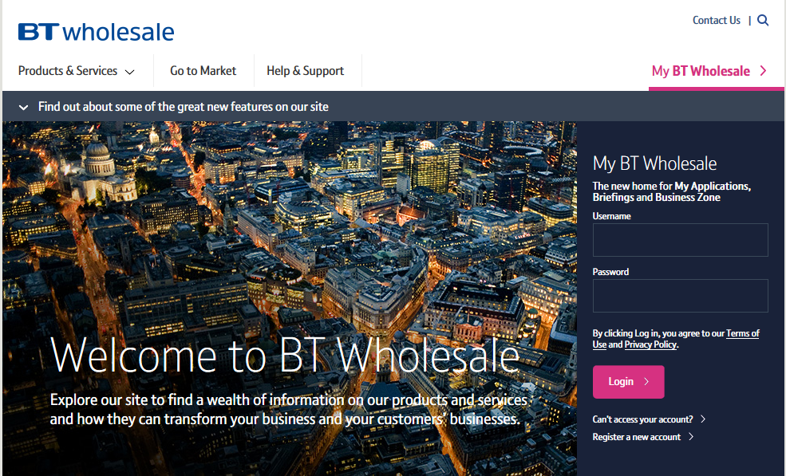

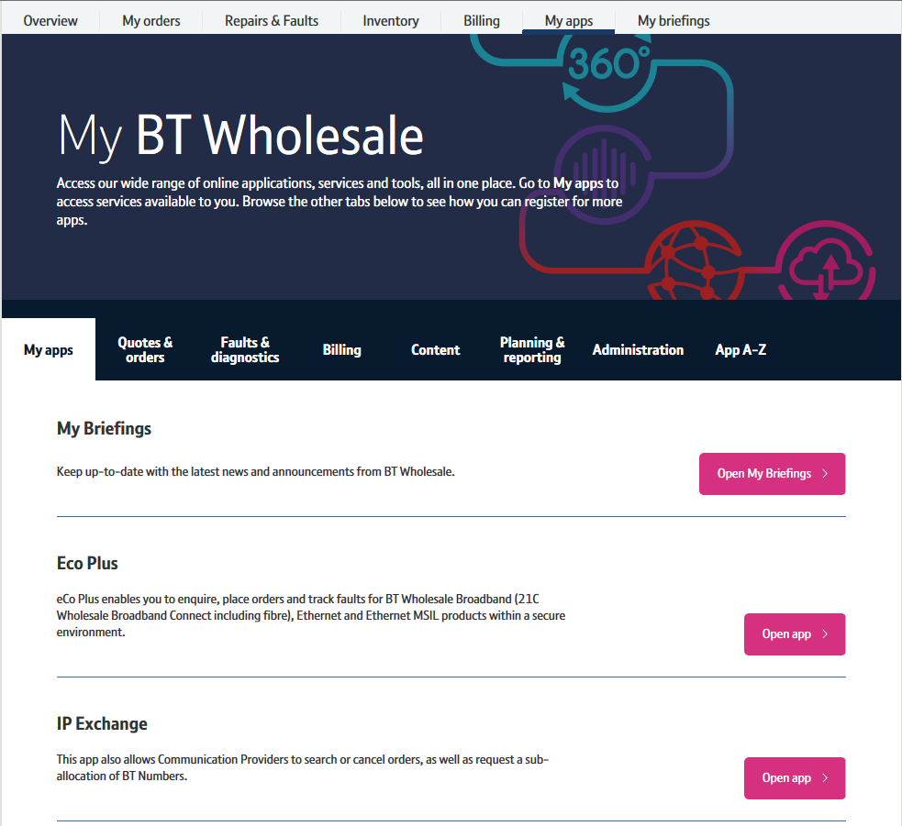

  - Lead times

Importing Lead Times

Installation type | Lead Time (W/D) | Sub Port (W/D)
Single Line | 4 | 7
Multi Line (30 Lines less) | 7 | 10
Multi Line (31 lines – 150 lines) – Simple DDI | 10 | 13
Multi Line (151 lines or more) – Capacity check may be required | 17 | 20
Complex DDI | 22 | 25

Exporting Lead Times

Installation type | Lead Time (W/D) | Subsequent Port Leadtimes (W/D)
Single Line | 4 | 7
Multi Line (30 Lines of less) | 7 | 10
Multi Line (31 lines – 150 lines) – Simple DDI | 10 | 13
Multi Line (151 lines or more) – Capacity check may be required | 17 | 20
Complex DDI | 22 | 25

Note: For exports that require increases to network capacity a revised porting date may be needed to allow time for network capacity to be increased.
Scenarios 4 and 6 are excluded from timescales for Multi Lines of 31 – 150 lines. These are classed as Complex orders. Scenario 7 orders are the responsibility of the rangeholder to meet the reduced leadtimes.

  - Placing an IMPORT Request for geographic numbers

Placing a Single Line Porting Request

Select Single Line porting facility.

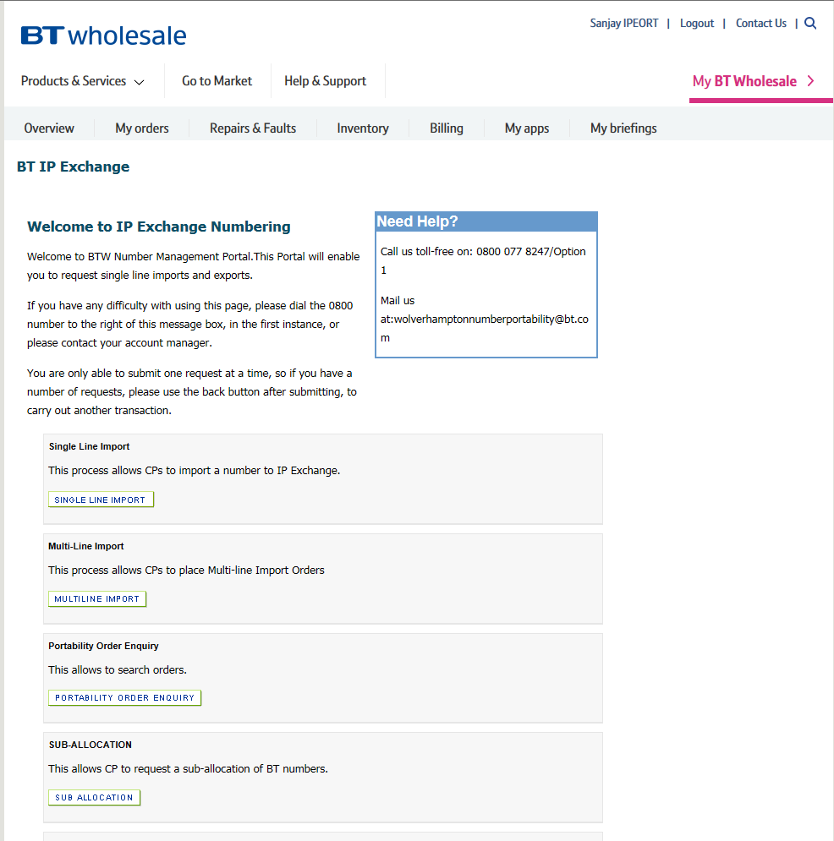

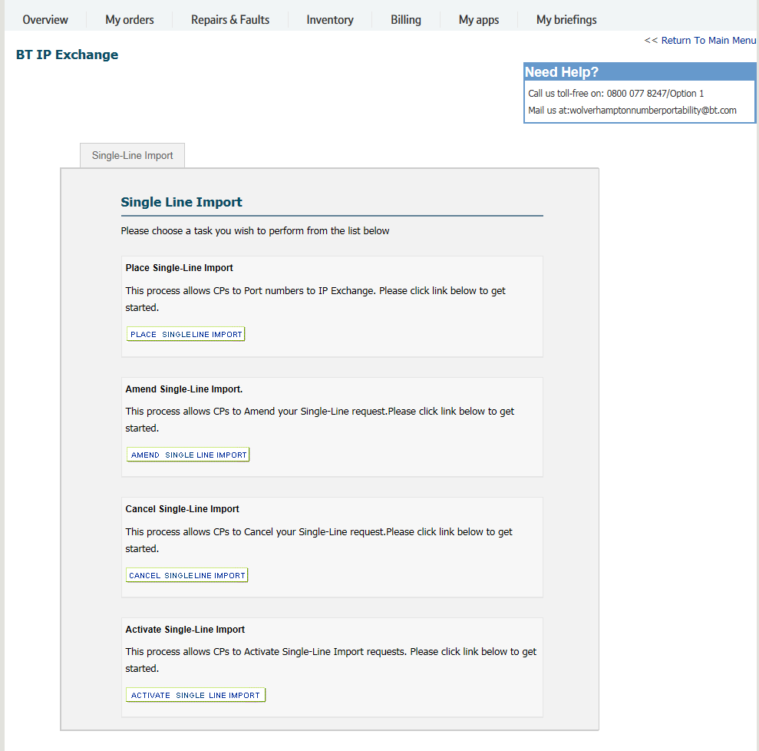
Complete the fields on the Porting Form once you have selected the Single Line Import button.

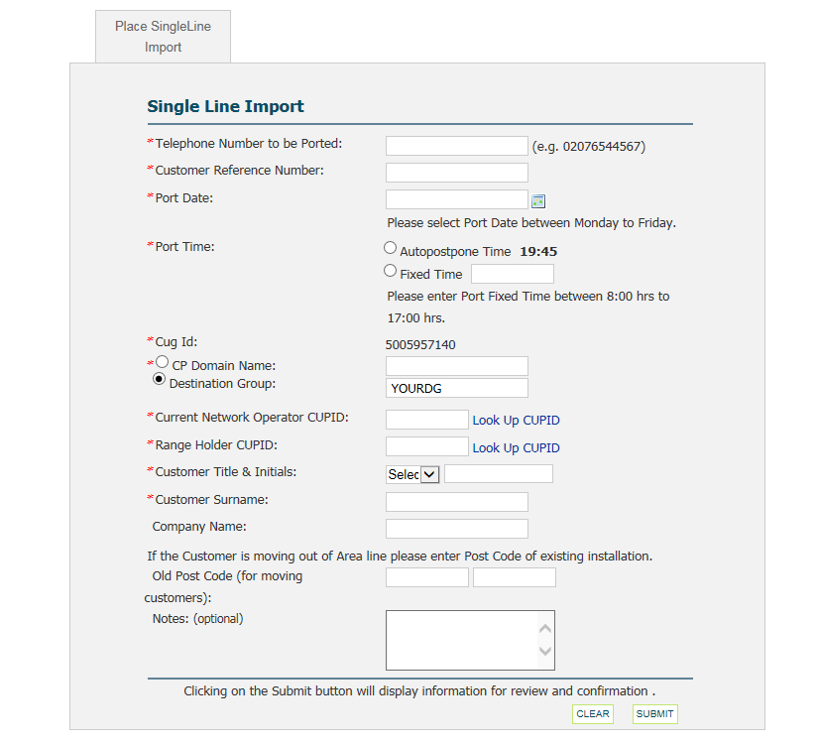
Complete mandatory fields as required.

Please note that it is essential that the “Old Post Code” section is completed where end users are moving from their existing location. This is to ensure that the Emergency Services Database is correctly updated.

Responses to Customer Following Porting Request

Once you have placed your port request, you will receive a number of notifications. These will include the telephone number to be ported and confirmation of the date of port from the Losing CP.

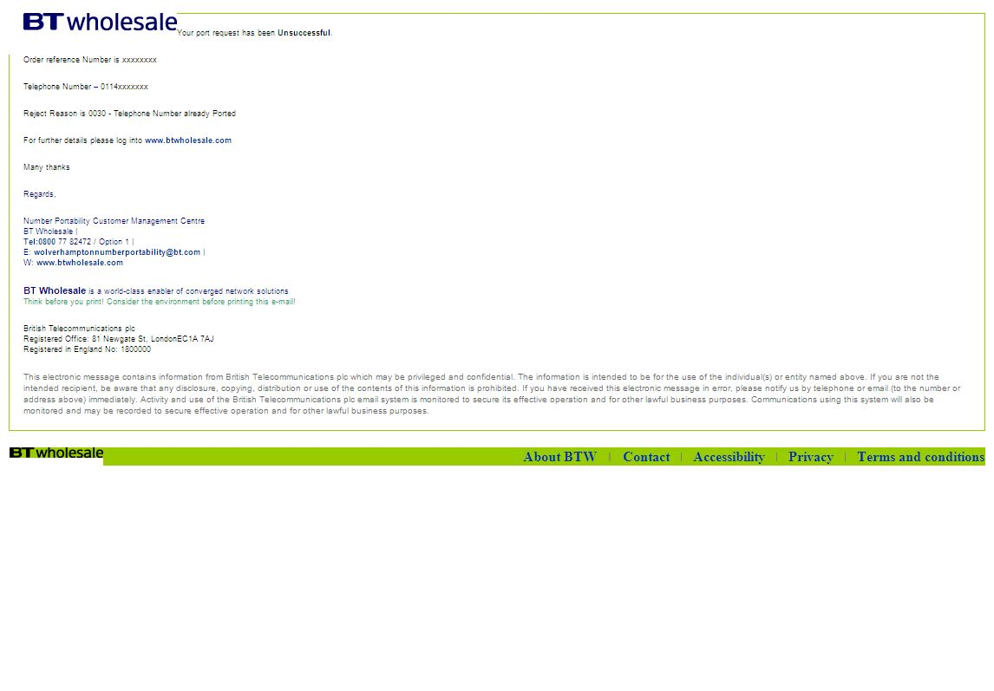

If the request is rejected, we will provide details of the rejection codes as stated within the GNP end to end process manual [section C] at http://www.offta.org.uk/best.htm
Due to the nature of the porting process and the date when responses are received from the Losing CP and/or Rangeholder, accept or reject responses may be returned in multiple files. These may not be in the order sequence that was originally presented to the IP Exchange service desk.

If a number requested for porting belongs to a CP who has not been Service Established (SE) with the IP Exchange Porting Prefix, then we may request SE to be done. If it has been agreed that BT will enter into SE arrangements with the Losing CP the process could take up to 85 working days, and in some instances even longer. The IP Exchange service desk will inform the customer of the date that the SE process is expected to be completed.

Cancellation and Amendments of Single Line Ports

Cancellation and amendment orders are submitted via the IP Exchange Number Management Portal.

Cancellations

Ports can be cancelled up to 16.00hrs, on the last working day prior to the Customer Required by Date, CRD.
- This can be done by: Select Single Line import on the Portal,
- Select Single Line Cancel button
- Search / enter your reference number or the telephone number to be ported
- Detailing the reason for cancellation
- Selecting ‘cancel this order’.

Once cancelled, a new porting request must be submitted for the number if it is required to be ported in the future.

Amendments

Ports can be amended up to 16.00hrs, on the last working day prior to the Customer Required by Date, CRD.

If other information is required to be amended, then a cancellation of the port must be requested and a new porting request submitted.

Please note that the following elements are not allowed or supported for Scenario 4 orders:
· Date Changes on Single Line requests cannot be supported.
· Emergency Restoration Requests

On the Day of the Port

Fixed Time Ports

The Range Holder will apply the IP Exchange Porting Prefix in their network for the number to be ported. The IP Exchange routeing engine will be configured for that number at the time indicated on the porting order.

BT cannot guarantee exact synchronization between these two actions.

Please note: Prefix Changes (PXCs) are FIXED time in all cases, they can’t be requested as Real Time Activations.

Real Time Activation/Auto-postpone Ports

Where the Gaining CP has requested a Real Time Activation/Auto-postpone port, the date given in the porting request is the start date of the seven day auto-postpone period

To activate the Port, the Gaining CP needs to:
- Activate the number via the IP Exchange Number Management Portal using the Activate Single Line Import option
- Once the above step has been completed, this will generate an email which will notify the Range Holder. Losing CP to export the number.

Ports can be activated up to 7 working days past the original requested date by using the Activate option in the Single Line Activation option.

Problems during Porting and Emergency Restore requests

CPs should contact the IP Exchange service desk if a problem occurs that they attribute to the BT service or the Losing CP network.
The IP Exchange service desk will check if there are any IP Exchange platform issues that could be causing the problem, before liaising with the Losing CP (via Openreach if appropriate).
The Emergency Restoration Order can be used by the Gaining CP to restore service to a ported customer when full service has not been provided following the attempted port. Instances when this arrangement is to be used should be very few, as the Gaining CP should ensure their own network is operational before activating the port. Emergency Restorations (ERs) may be requested up to close of business the day following the activation of the port.
These requests can be made by completing an NPOR form, with the order type set at ‘EMR’, and sending it to the IP Exchange porting service desk via e-mail, quoting the telephone number to be restored.
The IP Exchange service desk will request the Emergency Restoration and will inform the Gaining CP if the Losing CP has agreed. Charges may be applied by the Losing CP if a request is made to restore service after the Emergency restoration period.

Note: There are a number of scenarios where an Emergency Restoration will not be possible because the original access line is not available to the LCP. These include:-

- Where the end-user has moved to a new address as the LCP will not have an access line available.
- Access lines that have been fully unbundled (LLU)
- Subsequent Portability, as this will require data to be restored on more than one network. It is expected that Range Holders (where not the LCP) will assist as promptly as possible, and will be contacted by the GCP only. This includes Scenario 4 orders where a Rangeholder number, currently on import to BT, is then subsequently ported to IP Exchange.

Port Completion

When a port is completed, the gaining IP Exchange CP will receive an e-mail confirming port completion.

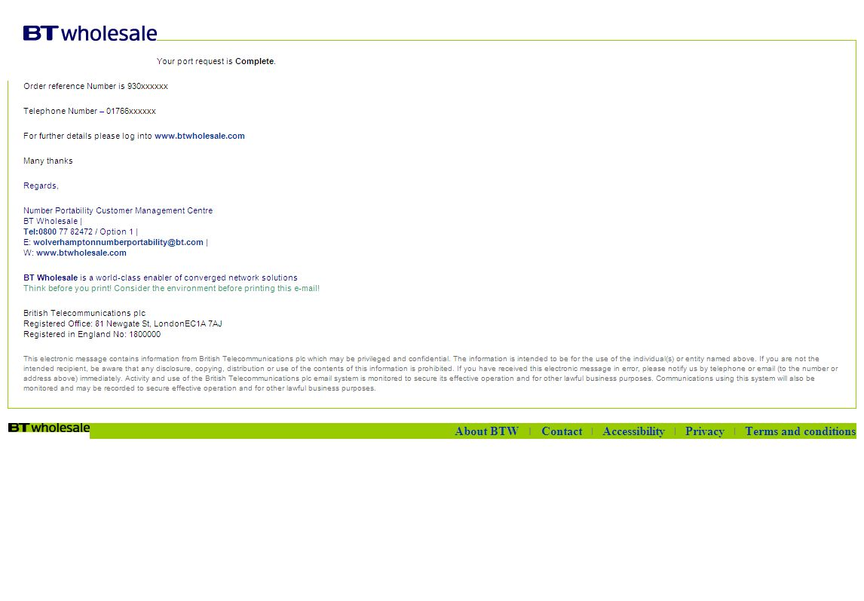

  - Multi-line Porting Requests for Geographic Numbers

Making a Multi-Line Porting Request

Requests are made via the IP Exchange Number Management Portal for multi-line porting requests that fit into the following categories:
Installation type | Lead Time (W/D) | Subsequent Port Leadtimes (W/D)
Single Line | 4 | 7
Multi Line (30 Lines of less) | 7 | 10
Multi Line (31 lines – 150 lines) – Simple DDI | 10 | 13
Multi Line (151 lines or more) – Capacity check may be required | 17 | 20
Complex DDI | 22 | 25

It is imperative that the installation address is 100% correct when placing the order. This is to avoid the order being ejected by Openreach and/or the Losing CP. This address is used initially to validate the order and, in the later stages of the order provision, to update the ESDB.
It is mandatory that the installation address is used on the submitted order, this is required for ESDB purposes.

Multi-line capacity planning

It is the responsibility of both CPs to ensure that the necessary capacity is available as degradation of service may occur to ported calls and also other calls transiting the networks.

The RH will be required to conduct a capacity planning study for a porting request from a GCP where calls are delivered to 31 lines or more. This study will assess whether sufficient capacity exists within the RH network to carry the increase in traffic when porting the numbers. On receipt of the order the RH must provisionally accept or reject the order within 2 working days.

Once provisional acceptance is provided the capacity planning exercise will commence and be completed within 10 working days. On completion of the study the RH will inform the GCP of the result with an Accept or Reject for Capacity Planning timescales.

If the capacity planning study identifies the need to increase network capacity a revised porting date will be advised to the GCP with the reject code. The GCP may then re-schedule the porting date to the date quoted by the RH or beyond by submitting a re-present order. If the order is not re-presented by the GCP within 2 working days of completing the study the required network capacity upgrade work will not be undertaken by the RH and the port order will time expire.

The following table shows some examples of installation types that require a capacity planning study.

Number of lines on the GCP Network | Capacity Planning Required
Multiline PBX 31 lines and over | Yes
Combination of Multiline PBXs which collectively are 31 lines and over | Yes
Combination of Multiline PBXs and Single Line PBXs (i.e. S/L terminating on PBX equipment) which collectively are 31 lines and over. | Yes

Where the GCP is not installing a physical access line, they should insert the total number of numbers to be ported to enable the LCP to decide if a capacity planning check is required.

Cancellation and Amendments of Multi-line Ports

Orders can be cancelled or amended up to 16:00 on the working day prior to the porting date by using the Multi-Line Cancel or Amend facility within the IP Exchange number management portal.

An “Amend” order may be submitted to change the port date to one which is later than the date originally requested. The Amend order can be submitted using the Amend Multi-Line Import option. Orders will be validated within 48 hours of submission.

If changes to the CUPID, order number or telephone number(s) are required, then the original order must be cancelled and a new order submitted.

Day of Port for Multi-line

On the day of port, the Gaining CP should request, via the IP Exchange Number Management Portal, that the numbers to be ported are configured on the IP Exchange Core Routeing Engine, using the Configure Multi-Line import option. The Gaining CP will contact the IP Exchange service desk to initiate the transfer of service into IP Exchange. The numbers will become active within 15 minutes i.e. Active on IP Exchange however, BT cannot guarantee exact synchronization between these two actions.

If the port is not going to be activated on the specified porting date, the Gaining CP should request a date change via the IP Exchange Number Management portal.

Post Port Activities

After the port has been successfully completed, the IP Exchange service desk will update the Emergency Services Database, using the name and address information supplied in the order. Any changes to the address of the end user must be notified to BT by using the Premises move option on the IP Exchange Number Management Portal.

7.3.6 Import of a Mixed Range Holder port

This supports the porting of multiline numbers from a LCP that could contain number ranges owned by different range holders.

As the GCP you should place a Multi-Line import order request via the Portal for a mixed range holder order by selecting option “Yes” against “Mixed range holder order”, as seen in the screenshot below. This does not include Mixed Losing CP ports. Where a number is already on export to another CP this should be submitted as a separate order.

You should enter the Main Billing number ,DDI ranges , associated number(s) and other numbers as applicable for ML (applicable actions are Port, retain and cease).In addition you should also enter the list of number ranges and range holder CUPID information in the Mandatory Notes field, as per screen shot below.

It is of the utmost importance that this free text box is completed with all the information, to reiterate, this should include details of which numbers are to be ported and who the Range Holder is and appropriate CUPIDs.

Date charges are permissible.

Subsequent Port of a Number Currently Working with BT to IP Exchange - (Scenario4)

Please note that the following elements are not allowed or supported for Scenario 4 orders:
· Date Changes are not supported for Multi Line requests.
· Emergency Restoration Requests

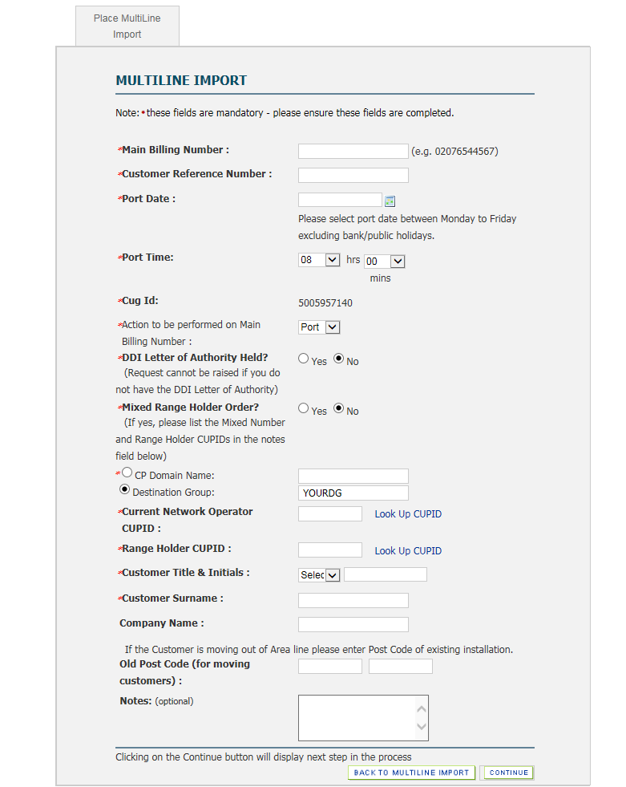
All relevant KCI’s for Mixed Range Holder ports will mirror those currently received for Multi-Line orders.

  - Export of a BT sub-allocated geographic number

BT Sub allocated numbers

Upon receipt of a number export request, the BT IP Exchange service desk will validate the order and, if valid, provide the Losing CP with an AOT (Advise of Transfer) to notify you when the export will take place.

If validation fails this will be managed by the IP Exchange team (you will not be aware that a request has been received if rejected).

If the Losing CP successfully retains their customer, they need to send a NPOR – order type Cancel Other (COT), to the IP Exchange service desk to notify us that the export request should be cancelled. This will be sent to the Gaining CP.

  - Non-geographic number portability (NGNP)

Import

IP Exchange can import / export Non-geographic numbers e.g. UK Numbers that begin with: 03*, 0800*, 0808*, 0843, 0844*, 0845*, 0870*, 0871* and 090* numbers

Orders are submitted by using the www.btwholesale.com portal, on the relevant letterhead paper with the appropriate supporting documentation as provided in Section 11 Annex B.

The full Non Geographic Number Porting Pack comprises:

- The Notice of Porting for Non-Geographic Numbers form – Completed by Gaining CP on their Letter Head
- A Customer Requirement Form – Completed by IP Exchange Representative
- A Customer Requirements Form appendix (Spread sheet of the requested numbers if more than 3 are to be ported under the same request) – Completed by the Gaining CP.

Please note: 50 numbers can port per day - per order received e.g. an order with 250 numbers will port over a 5 day period. However, for large orders, in excess of 500 numbers, we will try and port more services per day to get the whole port completed, however this is not guaranteed as it’s dependant on the CPs/ resellers involved.

Export of a previously imported number

The BT IP Exchange service desk will validate the order and, if valid, provide the Losing CP with an AOT (Advise of Transfer) to notify you when the export will take place.

If validation fails this will be managed by the IP Exchange team (you will not be aware that a request has been received if rejected).

If the Losing CP successfully retains their customer, they need to send a NPOR – order type Cancel Other (COT), to the IP Exchange service desk to notify us that the export request should be cancelled. This will be sent to the Gaining CP.

  - Export of an IP Exchange Communications Provider Hosted Number Ranges (Scenario 7 export requests)

This chargeable managed product can be used to facilitate requests for exports of CP hosted number ranges.

Please note the following are excluded from Scenario 7 export requests;

- Mixed Range Holder port requests
- Mixed Losing CP requests
- Re-presents
- Return to Range Holder (GNP)
- Subsequent Port (GNP)

Date changes are permitted.

Type B Communication Providers (Billing to same level as TDM interconnect) remain responsible for meeting General Conditions of Entitlement B3 export requests.

It remains the Range-holder’s responsibility to ensure the Emergency Services Database is updated. Details of how to do this are contained in the IP Exchange Product Handbook.

Advice of Transfers, AOT, can only be sent to one nominated E mail account. If IP Exchange CP’s did not respond to the request for information of where to send the Advice of Transfer the AOT will be sent to a contact/email address we have selected within your company.

If you do not receive an AOT please contact us, in the first instance, and we will confirm where the AOT has been sent to.

Should this address need to be changed we will endeavour to do so at the earliest possible opportunity but, until such time as we are able to affect the change, AOT’s will continue to be sent to said address.

Additionally please note, automatically generated KCI’s will also be sent to this email address.

Any ports carried out using this service will mean you will no longer receive traffic to those exported numbers as the portal will automatically route these calls to the Gaining Communications Provider without routing them to your switch first.

Export of an IP Exchange Hosted Number to another IP Exchange CP including Subsequent Port requests – On-Net Port

If a request is received to export an IP Exchange CP hosted number, the Rangeholder will receive an Advice of Transfer, (AOT).

When a request is received for a subsequent port request, the Losing CP will receive an AOT (Advise of Transfer) to notify you when the export will take place.

If the Losing CP successfully retains their customer, they need to send a NPOR – order type Cancel Other (COT), to the IP Exchange service desk at wolverhamptonnumberportability@bt.com to notify us that the export request should be cancelled. This will be sent to the Gaining CP.

As the Range Holder, if you wish to use the chargeable managed service, you will be required to log on to the portal and either Accept or Reject the order. (See screenshot below)

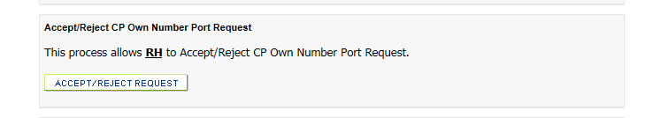

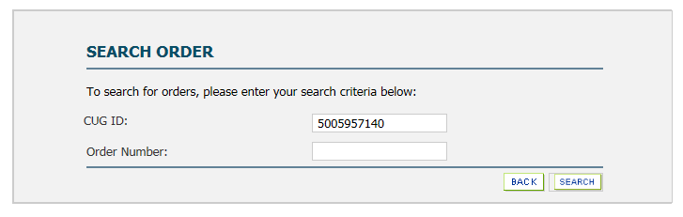
If you choose to Accept the order, the order will then be progressed on your behalf.

Remember, as the Rangeholder for this number, it is your responsibility to update the Emergency Services Database. Details of how this should be done can be found in the IP Exchange product Handbook.

Export of an IP Exchange Hosted Number to a non IP Exchange CP – Off-Net Port

If you receive a request from a non IP Exchange CP to export one of your hosted geographic and Non Geographic numbers you may choose to use the chargeable managed product, Scenario 7, to facilitate that request. The screenshots below detail the process steps that the Rangeholder needs to complete in order to complete the export request.

When a request is received for a Subsequent Port request, where the Losing CP is an on-net IP Exchange CP they will receive an AOT (Advise of Transfer) to notify when the export will take place. Where the Losing CP is an off-net IP Exchange CP the Rangeholder will be responsible for the generation and sending of the AOT (Advise of Transfer) to notify when the export will take place.

These requests should come to you directly from the Gaining Communications Provider.

The following instructions are applicable for both single and multi-line journey, whichever is appropriate.

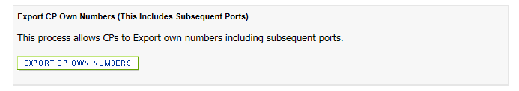
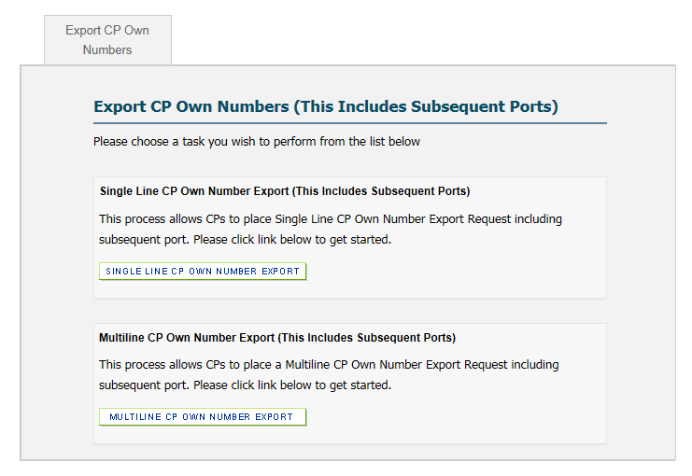

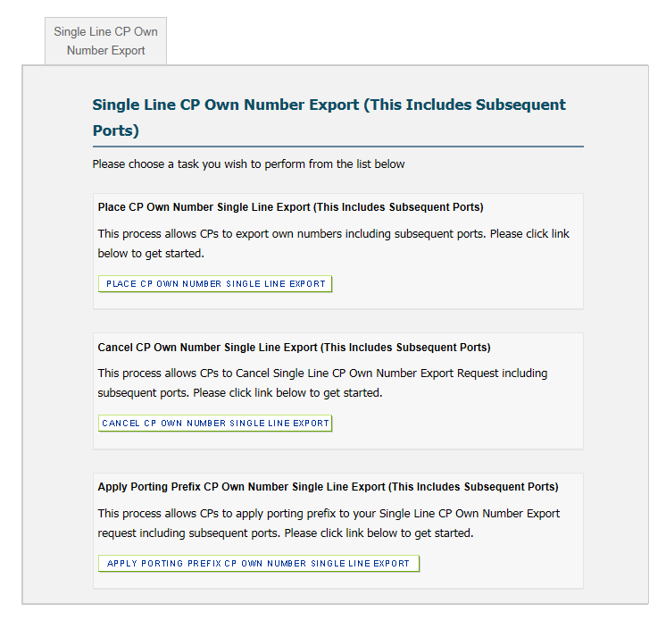

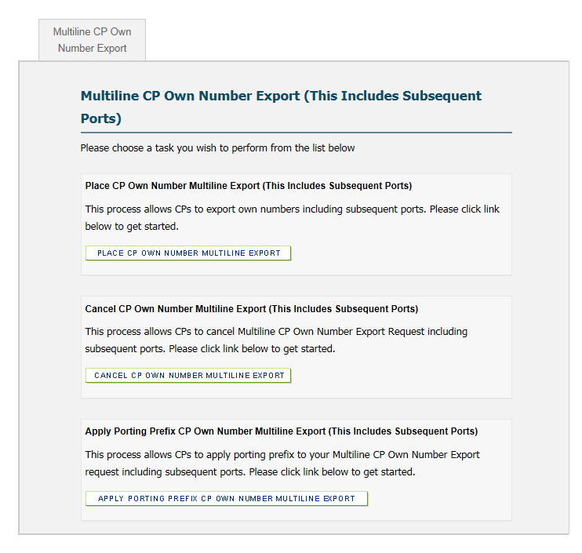

You will receive the KCI message, example below, which shows the order as being “Accepted”. On the day of port you should then log back into the portal and click on “Apply Porting Prefix CP own Number” for S/L or M/L, whichever is applicable.

It is the responsibility of the Range-holder to keep the Gaining Communications Provider informed of order progression throughout the order journey.


Your port request Export CP Own Numbers has been Accepted
Order reference Number: 931558860
Telephone Number: 01234 456789
Please log into www.btwholesale.com to "Apply the Porting Prefix".

Please note: that the order will be rejected if the request to apply the porting prefix is not received

The embedded document below details the process steps in flow diagram format of the steps to be taken when using the chargeable managed service for the exporting of IP Exchange CP Hosted Geographic numbers. This includes a diagram of the specific steps which the responsibility of the Rangeholder.

Remember, as the Range-holder for this number, it is your responsibility to update the Emergency Services Database. Details of how this should be done can be found in the IP Exchange product Handbook.

If there is a fault with a hosted number that has exported to a non-IP Exchange CP then the IP Exchange Range-holder should raise the fault request on behalf of the GCP and keep the GCP informed of progress.

Return to Range-holder requests for previously exported CP Hosted Numbers

Return to Range-holder requests should be placed as an import request. This is similar to the request made when a number is gained from another CP.

- Complaints handling

Any complaint regarding the IP Exchange service should in the first instance be directed to the IP Exchange service desk for resolution. Should a customer remain dissatisfied they should follow the escalation procedure detailed in their Customer Service Plan.

- Glossary of Terms

AOT | Advice of Transfer
CP | Communications Provider
CUG | Customer User Group
ID | Identity
GCP | Gaining Communications Provider. The Communications Provider with the network that the Number is to be ported to
IP | Internet Protocol
LCP | Losing Communications Provider. The Communications Provider with the network that the Number is to be ported from.
PSTN | Public Switched Telephone Network
RH | Range Holder
SE | Service Establishment
DDI | Direct Dialling In
NGNP | Non-geographic Number Portability
GNP | Geographic Number Portability
VoIP | Voice over the Internet Protocol
NPOR | Number Portability Order Request
EMR | Emergency Restoration

- Annex A: Portal Error Messages

11 Annex B: Documentation

Attached are the required forms for completion for any Non Geographical Numbers requiring Porting. e.g.: 0800*, 0808*, 0844*, 0845*, 0870*, 0871* and 090* numbers

1) "Porting of Non Geographic Numbers Notice" - **NB** must be copied onto customer's Letter Headed paper. The document is also known as Authority of Notice to Port and must be completed by customer on their Letter Headed paper for confirmation, signed and dated.

Their current CP name and address details and the New CP name and address details must be completed. If the new CP is BT then the details are as follows - Name: BT PLC, Address: 81 Newgate Street, London EC1A 7AJ.

Customer Name and Address must be filled in, but most important is the Account Number (with their current CP). A copy of their invoice would also be useful to confirm their Account Number with the losing CP, as this information is sent to the losing CP by NGNP Openreach after "validation" by BT.

If the customer is porting more than one number, the Account Number must be correct for all numbers to port as they may have different Account Numbers for each one porting and the Account Numbers must be associated with the correct number.

If there are too many numbers to fit on NGN Notice to Port form in Non-GEOGRAPHIC Number[s] to be ported section, then please use additional form below, with tabs for 30, 40, 50 and 70 numbers.

Note: There is an NOT Emergency Restore process for NGNP.

12 Annex C: NGN CP Owned Hosted Numbers Screen Shots

Raising an order (to port a NGN CP Owned hosted number to an IP Exchange CP)

Select Geograpgic Number porting
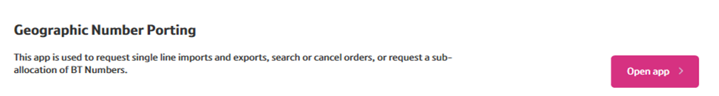
Choose the option “Non Geo Import”
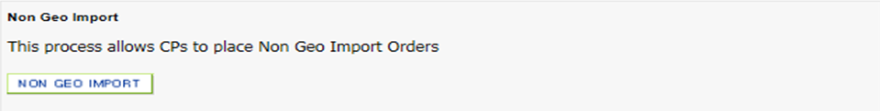
To submit a new order select: “Place Non Geo Import”
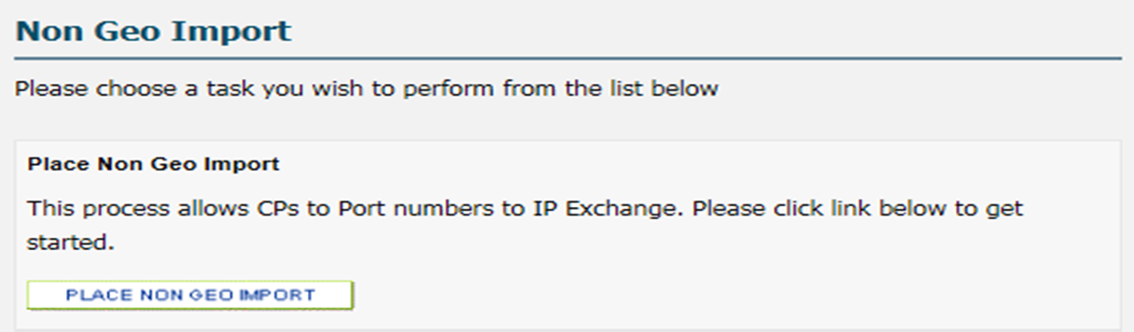
The screen below will appear. Customer CUG and billing account will pre-populate.
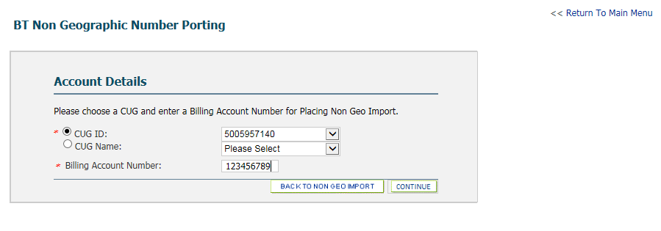

The order entry screen will appear. Fill out the order and press continue.
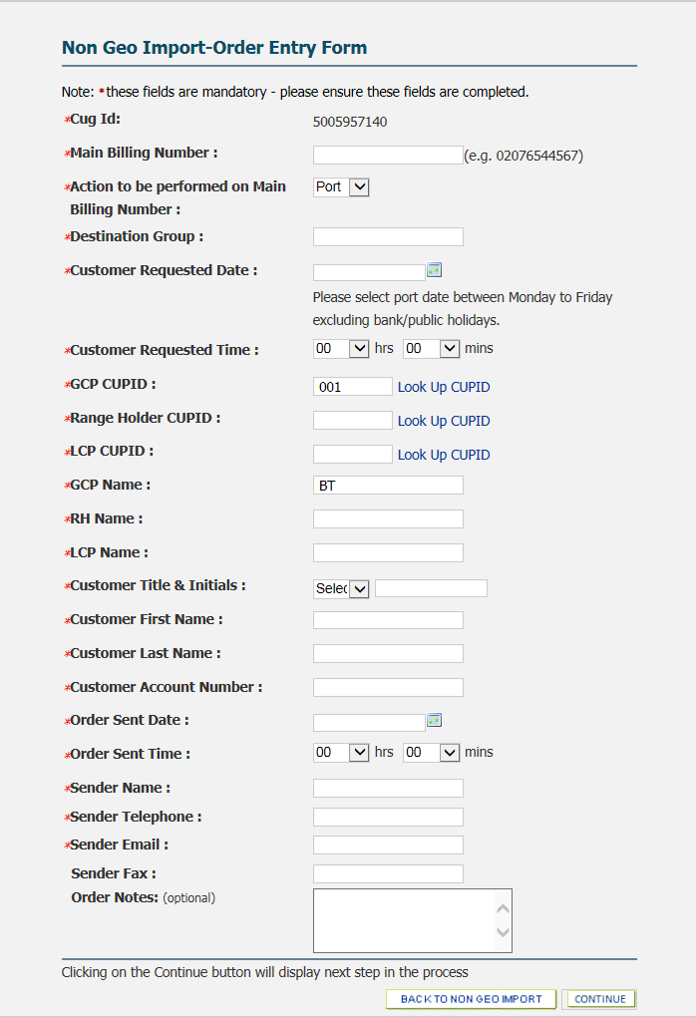
We’ll only need your first name as a point of reference here.
The time & date when raising the order
Account number as it appears on their invoices.
The name of the person who signed the LOA
The ‘lead’ Number on your order.
Where IPEX will route the calls to
Information you feel needs to be included with the order.
LCP / RH CUPID i.e. 001
If you have sequential numbers you can add them the ‘Ranges’ Section. Any remaining numbers can be supplied in the ‘Other’ cells. If you need to add more click on the
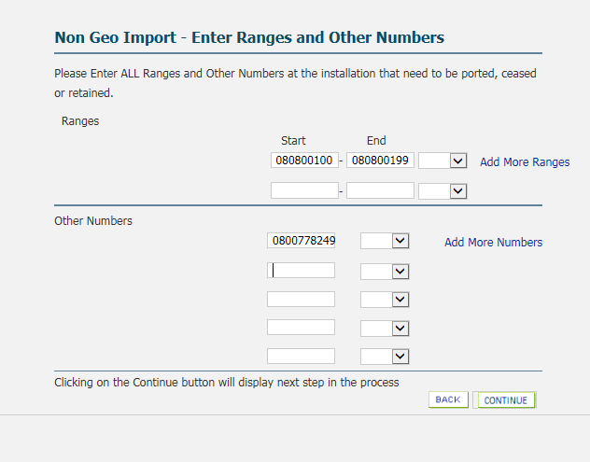
If you need more cells for additional numbers, just click ‘Add more numbers

Now you’ll need to add the post code for your customer. We have an address lookup available.
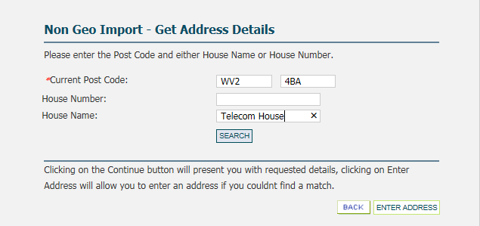

The address lookup is displayed below.
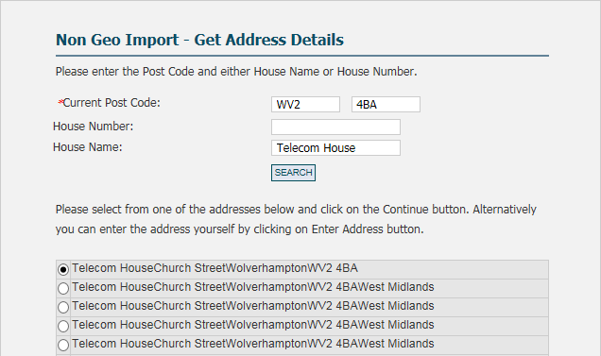

Once you’ve selected the address: Press continue.
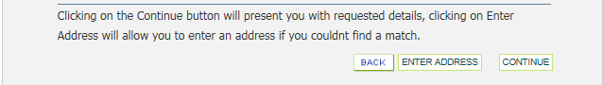
The portal will provide an order summary page. If you’re happy to continue: Press Submit.
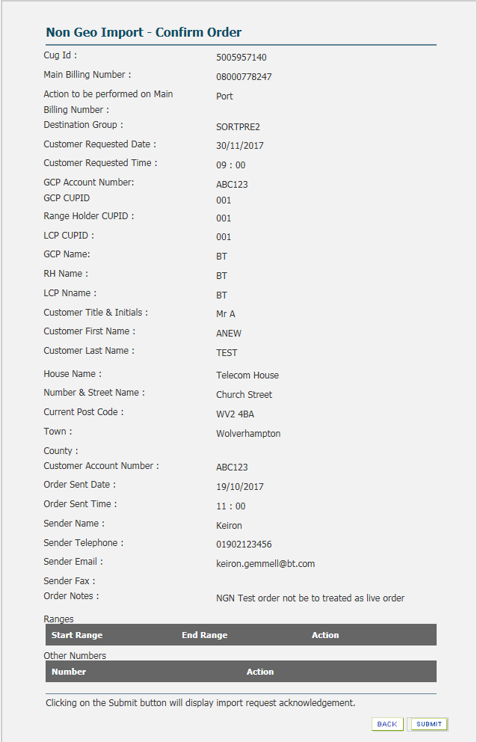
The screen below will appear. Select: Browse to locate your saved copy of the LOA. Submit once inserted.
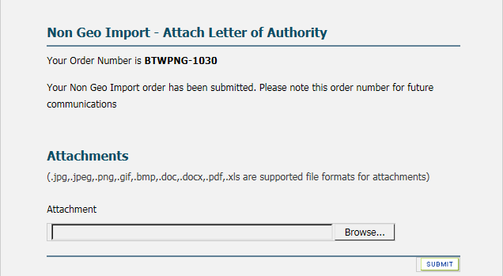
Once submitted the portal will provide the NGN porting order reference starting BTWPNG
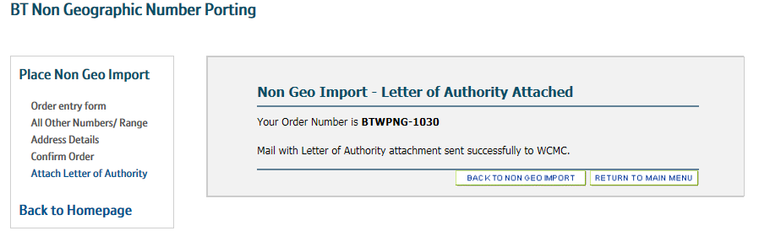
A KCI will be generated and sent to your chosen email address. (An example is provided in the KCI section)
A copy of your order will be validated by our portal. If the numbers submitted are hosted, we’ll send your order to the Range holder along with an AOT. If the numbers are not hosted the order will be dealt within the same manner as our current NGN’s.

Advice of Transfer:

An AOT and copy of the order is sent to the Range Holder. If a copy of the LOA is required please contact our porting team via e-Chat or email wolverhamptonnumberportability@bt.com to request a copy.

Subsequent AOT’s will be sent for any Amend (CHA) orders submitted.
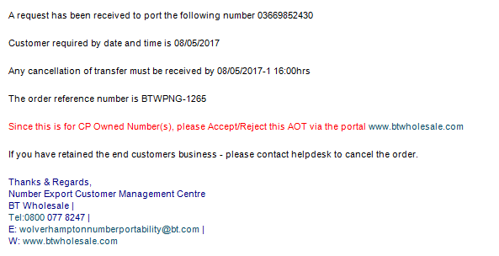

Accept/Reject: Range Holder
As the Range holder the orders sent to your nominated account will need to be accepted or rejected. Below we’ll provide guidance to complete this action:
Log into BTW.com and select Geographic Number Porting
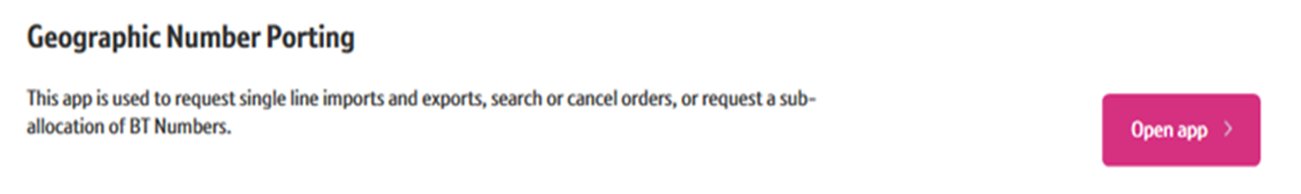
Select the option to accept/Reject CP Own Number Port Request
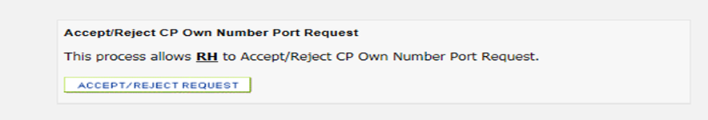
Enter the order Number i.e. BTWPNG-1*** and press search.
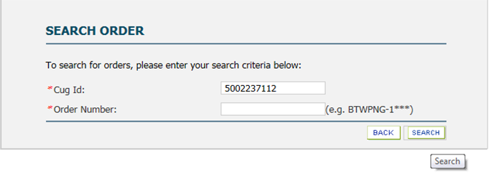
Select the action required, and press continue. (When rejecting please provide a valid reason)
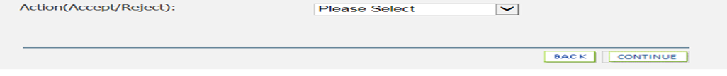
Upon completion of this task: A KCI will be sent to IP Exchange & the gaining provider.
The order will wait until the day of port OR an Amend / cancel own is submitted.

KCI: Order Acknowledged.
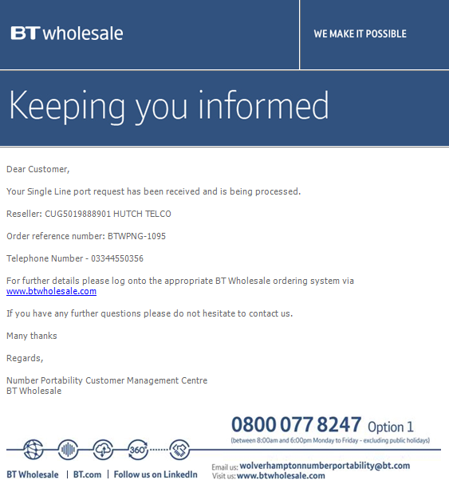

KCI: Order Accepted.
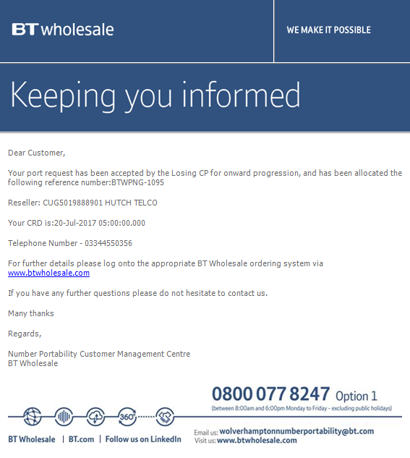

KCI: Porting Complete.

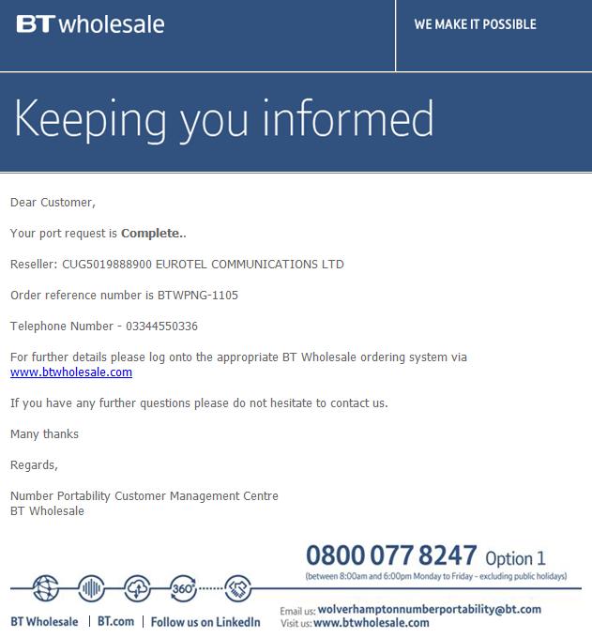

KCI: Cancellation Confirmation.

