Hosted Communications Services

INSERT LOGO HERE

[This area can be used to promote your brand. Your logo, the logo of the company with whom you are working, or other image can be inserted, and we advise using a JPEG file with a maximum height of 120px and a maximum width of 90px. If your image is smaller in width, we would recommend aligning your image to the right hand margin].

Datasheet

Using the Cloud to communicate

**The Cloud is reshaping the future of communications services**

Hosted applications such as IP Centrex, SIP Trunking and Hosted Contact Centre solutions are changing not just the way we all communicate, but the way we work – in the office, at home and on the move. Over 70% of UK businesses already use at least one fully deployed cloud-based application*.

* Businesses of 50 or more users. Source: ‘Cloud is becoming the new normal’ #SP02U, June 2012

Hosted Communications Services can take your business to the next level

With traditional voice services in decline, now’s the time to evolve your business and make the cloud work for you. We offer the latest technology, enabling you to react quickly to market opportunities, but without the challenges of having to manage costly resources and maintain levels of expertise   
in-house. Improve your customer service so you can respond quickly and flexibly to meet demand.

Our Hosted Communications Services are embedded within a next-generation network, providing built-in quality of service, security and resilience as standard, backed by extensive expertise, resources and reach.

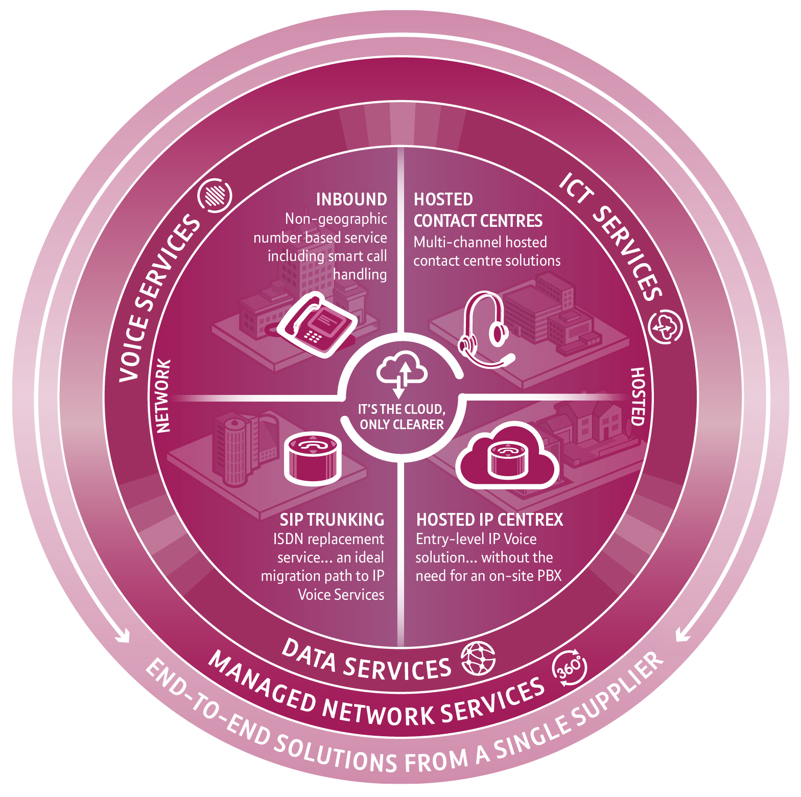

Datasheet

**Hosted Contact Centres**

Hosted Contact Centres (HCC) can be deployed quickly and simply. Our solution offers all the benefits of a high-performance contact centre – including voice, email, SMS, social networking and automated access – without the associated set-up costs of an on-premise solution. Our flexible commercials and scalability mean you can enjoy agile, responsive enterprise grade capabilities that will help you deliver a great customer experience and support your business growth ambitions.

**Inbound services**

Our Inbound Calls services give you all the flexibility of non-geographic numbers, smart call handling, dynamic call stats and analysis. You can have a Freephone, fixed rate or premium rate number that can be routed anywhere in the UK. We use a dedicated, high capacity, fully resilient network means you can choose how, when or where to scale up or down to match call demand – giving you complete control. And you can make the most of our inbound and outbound calls services by combining them to get even better rates.

Our Hosted Communications Services portfolio delivers more of the smart business tools you need, offering practical, cost-effective solutions that deliver high performance and reliability.

**SIP Trunking**

SIP Trunking bridges legacy and next generation voice technology, providing a simple first step towards unified communications without any major investment or disruption. The service allows you to keep your existing PBX and handsets, but benefit from enhanced functionality and significantly lower costs – in many cases up to 50% savings. It’s the ideal replacement for ISDN, offering greater flexibility, business continuity as standard, and can scale to suit all businesses.

**Hosted IP Centrex**

This is our industry-leading unified communications solution bringing together voice, video, presence and collaboration tools on any device, anywhere in the UK. As well as enabling smarter working, it offers lower call costs and advanced call handling. Because the service is hosted and fully managed, there’s no need for a PBX, no major up-front investment and operates on a pay-as-you-grow basis. It also integrates with our data connectivity products.

Make the most of the opportunities in this evolving world of IP

Datasheet

SERVICE & SUPPORT

[This section can be used to promote your service and support levels.   
Alternatively, you may wish to use this section to hold a promotional image. If text is required, we would recommend that you use the same font size for the Title of this section as you have for the other sections, this being a font size between 14pt to 24pt. For the main content in this section, we would advise using the same font size used for the other sections, between 11pt and 14pt. This information can be represented in a series of bullet points (optional).

If an image is required, we would recommend a JPEG file, with a maximum width of 260px. The height of the image can be based on the space available after completing the other sections.]

PEACE OF MIND

[This section can be used to promote your product/service reliability and also your experience and knowledge as a product/ service provider.

Alternatively, you may wish to use this section to hold a promotional image. If text is required, we would recommend that you use the same font size for the Title of this section as you have for the other sections, this being a font size between 14pt to 24pt. For the main content in this section, we would advise using the same font size used for the other sections, between 11pt and 14pt. This information can be represented in a series of bullet points (optional).

If an image is required, we would recommend a JPEG file, with a maximum width of 260px. The height of the image can be based   
on the space available after completing the other sections.]

PRICE STRUCTURE

[This section can be used to promote your product/service price offers.

Alternatively, you may wish to use this section to hold a promotional image. If text is required, we would recommend that you use the same font size for the Title of this section as you have for the other sections, this being a font size between 14pt to 24pt. For the main content in this section, we would advise using the same font size used for the other sections, between 11pt and 14pt. This information can be represented in a series of bullet points (optional)].

If an image is required, we would recommend a JPEG file, with a maximum width of 260px. The height of the image can be based   
on the space available after completing the other sections.]

MARKET POSITION

[This is where you can describe your company’s advantage over your competition – what sets you apart from your competitors?   
We would recommend that you use the same font size for the Title of this section as you have used for the other sections, this being a font size between 14pt to 24pt.

For consistency, we would suggest using the same font size for the main content in this section, as you have used for the other areas in this   
document, we would advise a font size of between 11pt and 14pt.]

The benefits can be shown in a series of bullet points   
(tick motif). The number of bullet points will be determined   
by their length and also the font size being used. We would suggest a font size for this content between 11pt and

14pt, allowing for approximately 6 bullet points in total].

Version: 1_310114