

Cisco Webex feature matrix by package
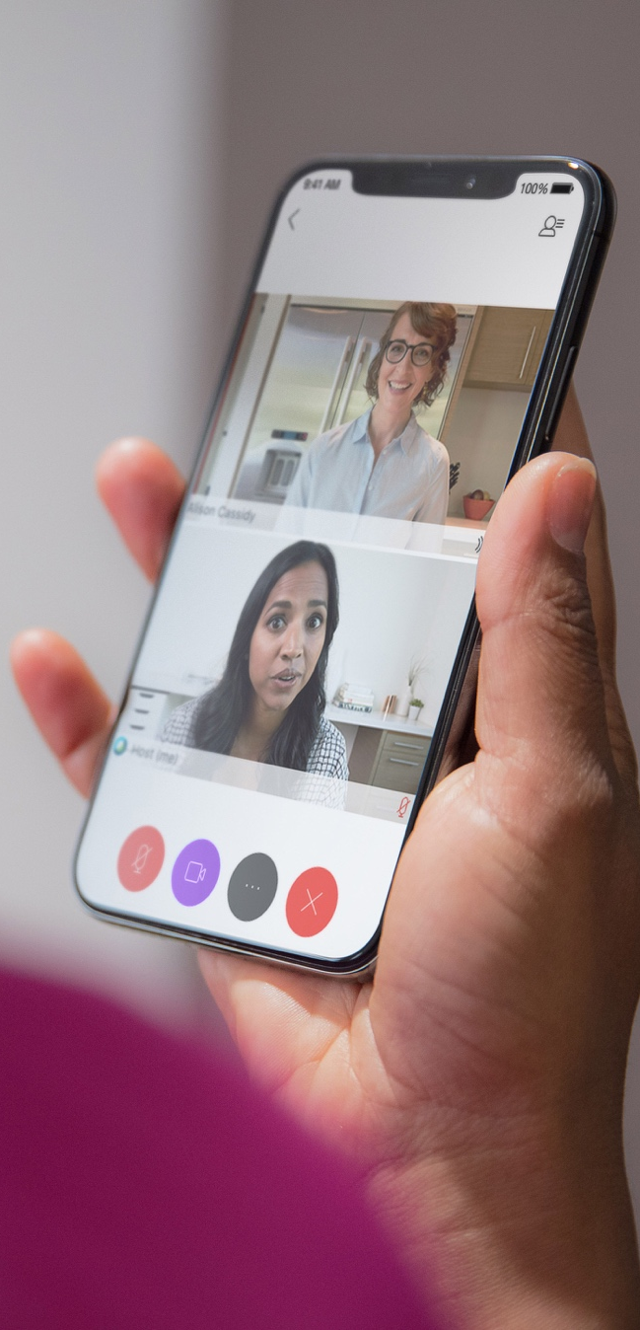
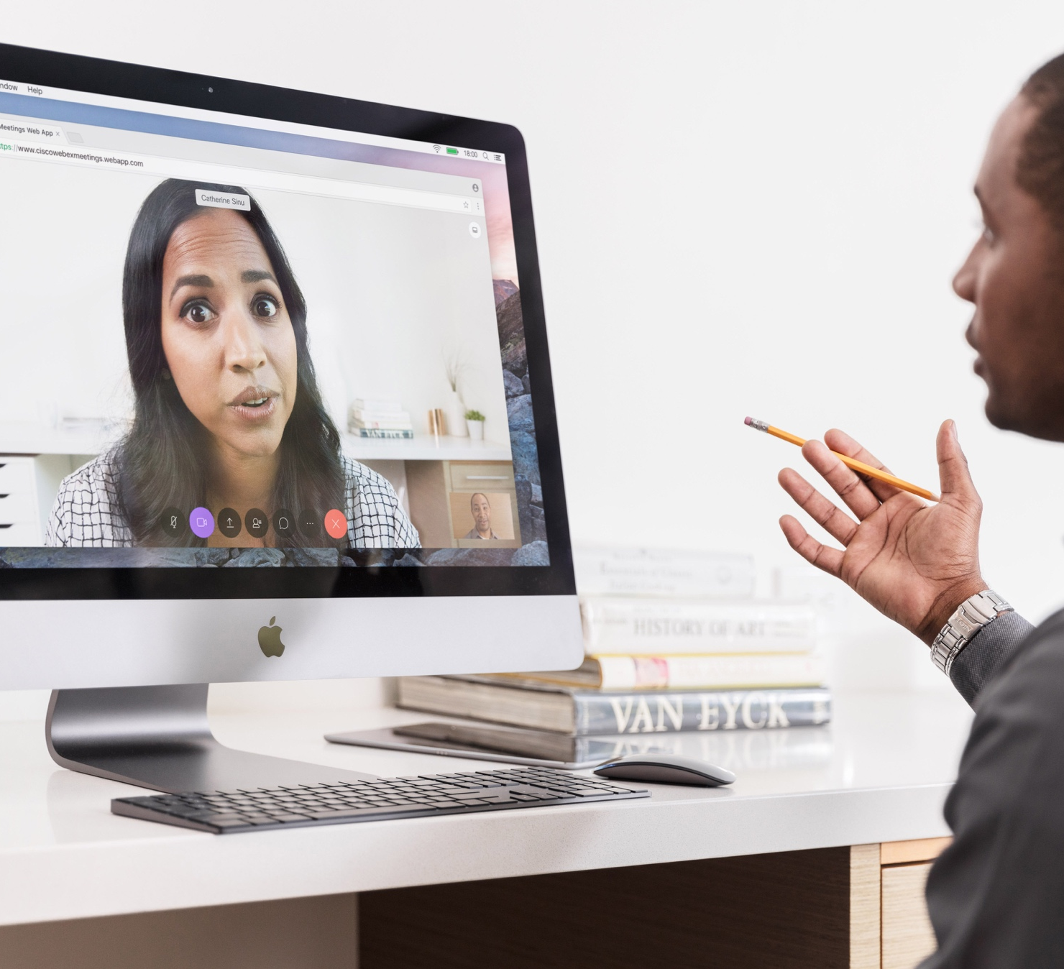

May 2021

Table of contents
Overview 2
Feature comparison by package 3
Calling** 3
Call settings 4
Personal contacts 4
Call history/voicemail 5
Search 5
Messaging 5
Basic messaging features 5
Advanced messaging features 6
Meetings 7
Common meeting features 7
Advanced meeting features 7
Additional 8
Protocols, security and troubleshooting 8
Accessibility 9
Peripherals 9
Calling configurability by service provider 9
Calling configurability by end user 9
CODECs – audio 9
Integrations 10

Overview

With Cisco Webex packages, enjoy the option to sell a mix of user configurations tailored to the unique needs of each employee in an enterprise and improve overall product adoption. Based on the rapidly changing needs of SMBs, organisations can deploy a variety of user configurations starting with a basic telephony user to an advanced collaboration user with the ability to host a 200-person meeting. Everyone can have exactly what they need and change packages whenever the need arises, at any time, with a simple click.

Softphone = Cisco Webex calling in Webex
Give your end users the ability to make and answer calls on any device with Cisco Webex softphone. The desktop, mobile, and tablet clients are all softphone capable. Depending on configuration, you give your end-user customer VoIP, call control, call through, and call back functions in the client and allow your customers to seamlessly transition calls between their desk phone, to their softphone, and even their mobile phone without interrupting the call.

Basic = Cisco Webex calling + messaging in Webex
Your end-user customers can use all of the softphone functions described above as well as instant messaging and presence (IM&P) features including direct and group messaging, Spaces, message persistence, screen sharing, files sharing, host 3-way Space meetings, guest meeting support, and more.

Standard = Cisco Webex calling + messaging + 25-person meetings in Webex
Your advanced end-user customers can use all of the functions described above (softphone and messaging), as well as highly secure video conferencing that allows you to host up to a 25-person voice and video conference, engage in multi-party chat, and desktop or application sharing. Invite guests to participate in a video conference through a web guest meeting experience. Finally, your users can enjoy a personal meeting room, dedicated only to them with their own conference bridge.

Premium = Standard package + 1,000-person meetings in Webex
When your end user needs enhanced meetings features such as meeting recording, remote desktop control, presenter controls, and recording transcription services, upgrade your end customers to the Premium package. They’ll enjoy all the features that come with the standard package plus the enhanced meetings features for up to a 1,000-person meeting.

Notes
Quarters represent target dates only.
Calling: * Supported through Call Settings Web View, ** All calling behaviour is provided by BroadWorks and licensed separately, *** Not supported in China

Feature comparison by package

 | Basic |  | Standard | Premium
 | Softphone | Messaging
Summary |  | Meeting Capacity  (PMR): 0  Space Meeting  Participants: 25  Meeting Duration:  24 hours  Message Storage:  2GB  Cloud Meeting Recordings: 0  Years Stored: 3 | Meeting Capacity  (PMR): 25  Space Meeting  Participants: 25  Meeting Duration:  24 hours  Message Storage:  5GB  Cloud Meeting Recordings: 0  Years Stored: 3 | Meeting Capacity (PMR): 1,000  Space Meeting Participants: 25  Meeting Duration: unlimited  Message Storage: 10GB  Cloud Recording: 10GB years  Years Stored: 5
Calling**
Place audio call (PSTN/VoIP) | ✓ | ✓ | ✓ | ✓
Receive audio call (PSTN/VoIP) | ✓ | ✓ | ✓ | ✓
Place video call | ✓ | ✓ | ✓ | ✓
Receive video call | ✓ | ✓ | ✓ | ✓
Dialpad | ✓ | ✓ | ✓ | ✓
Desk Phone Control (DPC):  basic incoming/outgoing calling | ✓  (Desktop only) | ✓  (Desktop only) | ✓  (Desktop only) | ✓  (Desktop only)
Desk Phone Control (DPC): mid-call features | Q3 ’21  (Desktop only) | Q3 ’21  (Desktop only) | Q3 ’21  (Desktop only) | Q3 ’21  (Desktop only)
Desk Phone Control (DPC): share | ✓  (Desktop only) | ✓  (Desktop only) | ✓  (Desktop only) | ✓  (Desktop only)
Desk Phone Control (DPC): join meeting | Q3 ’21  (Desktop only) | Q3 ’21  (Desktop only) | Q3 ’21  (Desktop only) | Q3 ’21  (Desktop only)
MNO: use mobile native OS for calling | May 2021 | May 2021 | May 2021 | May 2021
MNO: mobile single alert support | ✓ | ✓ | ✓ | ✓
MNO: mid-call control for native mobile call anchored on BWKS | Q3 ’21 | Q3 ’21 | Q3 ’21 | Q3 ’21
MNO: dual persona mobile | Q3 ’21 | Q3 ’21 | Q3 ’21 | Q3 ’21
MNO: display additional info for incoming mobile circuit switch calls | Roadmap | Roadmap | Roadmap | Roadmap
SIP URI dialling | Roadmap | Roadmap | Roadmap | Roadmap
Merge (N-way audio call) | ✓ | ✓ | ✓ | ✓
Conference (N-way audio call) | ✓ | ✓ | ✓ | ✓
Mute/unmute | ✓ | ✓ | ✓ | ✓
Hold/resume | ✓ | ✓ | ✓ | ✓
Transfer - blind | Roadmap | Roadmap | Roadmap | Roadmap
Transfer – semi attended | ✓ | ✓ | ✓ | ✓
Transfer - attended | ✓ | ✓ | ✓ | ✓
Sharing – screen, application | ✓ | ✓ | ✓ | ✓
Sharing – whiteboard and annotation | Q3 ’21 | Q3 ’21 | Q3 ’21 | Q3 ’21
Remote desktop control | Q3 ’21 | Q3 ’21 | Q3 ’21 | Q3 ’21
Call pull | ✓ | ✓ | ✓ | ✓
Group call park/retrieve | ✓ | ✓ | ✓ | ✓
Call pickup | ✓  (Desktop only) | ✓  (Desktop only) | ✓  (Desktop only) | ✓  (Desktop only)
Call push notifications (mobile) | ✓ | ✓ | ✓ | ✓
Call voicemail | ✓ | ✓ | ✓ | ✓
Call recording via 3rd party integration | ✓ | ✓ | ✓ | ✓
Feature Access Codes (FAC) | ✓ | ✓ | ✓ | ✓
Executive assistant (aka Boss Admin) | ✓  (Desktop only) | ✓  (Desktop only) | ✓  (Desktop only) | ✓  (Desktop only)
Register for tel: and callto: links | ✓  (Desktop only) | ✓  (Desktop only) | ✓  (Desktop only) | ✓  (Desktop only)
Seamless call handover between networks | ✓ | ✓ | ✓ | ✓
Call settings
Do Not Disturb – native, on soft clients | ✓ | ✓ | ✓ | ✓
Do Not Disturb – native, across all devices | Q3 ’21 | Q3 ’21 | Q3 ’21 | Q3 ’21
Do Not Disturb – across all devices* | ✓ | ✓ | ✓ | ✓
Call forward - always | ✓ | ✓ | ✓ | ✓
Call forward - busy* | ✓ | ✓ | ✓ | ✓
Call forward - no answer* | ✓ | ✓ | ✓ | ✓
Call forward - not reachable* | ✓ | ✓ | ✓ | ✓
Dual persona with mobility | Q3 ’21 | Q3 ’21 | Q3 ’21 | Q3 ’21
Call back (mobile) | ✓ | ✓ | ✓ | ✓
Call through (mobile) | Q3 ’21 | Q3 ’21 | Q3 ’21 | Q3 ’21
Simultaneous ring* | ✓ | ✓ | ✓ | ✓
Sequential ring* | ✓ | ✓ | ✓ | ✓
Hide number/block my caller ID* | ✓ | ✓ | ✓ | ✓
Voice messaging settings* | ✓ | ✓ | ✓ | ✓
Queues (call centre) - login/logout, status* | ✓ | ✓ | ✓ | ✓
Call waiting* | ✓ | ✓ | ✓ | ✓
Anonymous call rejection* | ✓ | ✓ | ✓ | ✓
Automatic callback* | ✓ | ✓ | ✓ | ✓
Video call – virtual background | ✓ | ✓ | ✓ | ✓
Background noise reduction | ✓ | ✓ | ✓ | ✓
Music mode | ✓ | ✓ | ✓ | ✓
Personal contacts
View all contacts | ✓ | ✓ | ✓ | ✓
Add new contacts | ✓ | ✓ | ✓ | ✓
Manage favourites | ✓ | ✓ | ✓ | ✓
Manage groups | ✓ | ✓ | ✓ | ✓
View profile | ✓ | ✓ | ✓ | ✓
Add contacts from common identity | ✓ | ✓ | ✓ | ✓
Call history/voicemail
Call logs - local | ✓ | ✓ | ✓ | ✓
Call logs - server based | July 2021 | July 2021 | July 2021 | July 2021
Call logs - delete all | ✓ | ✓ | ✓ | ✓
Call logs - delete individual calls | ✓ | ✓ | ✓ | ✓
Call logs (basic) – missed calls counter | Desktop: ✓  Mobile: June ’21 | Desktop: ✓  Mobile: June ’21 | Desktop: ✓  Mobile: June ’21 | Desktop: ✓  Mobile: June ’21
Call logs (enhanced) - show duration of calls | Roadmap | Roadmap | Roadmap | Roadmap
Call logs (enhanced) - show hunt group calls | Roadmap | Roadmap | Roadmap | Roadmap
Visual voicemail - view | ✓ | ✓ | ✓ | ✓
Visual voicemail - audio | ✓ | ✓ | ✓ | ✓
Visual voicemail - download | Roadmap | Roadmap | Roadmap | Roadmap
Visual voicemail - mark as viewed | ✓ | ✓ | ✓ | ✓
Visual voicemail - mark as confidential/urgent | ✓ | ✓ | ✓ | ✓
Third party voicemail support | ✓ | ✓ | ✓ | ✓
Search
CI search | ✓ | ✓ | ✓ | ✓
Universal search | ✓ | ✓ | ✓ | ✓
Outlook contact search | ✓  (Desktop only) | ✓  (Desktop only) | ✓  (Desktop only) | ✓  (Desktop only)
Local mobile contact search | ✓  (Mobile only) | ✓  (Mobile only) | ✓  (Mobile only) | ✓  (Mobile only)
Google contact search | ✓  (Mobile only) | ✓  (Mobile only) | ✓  (Mobile only) | ✓  (Mobile only)
Group common list/personal directory search | June 2021 | June 2021 | June 2021 | June 2021
LDAP contact search | Roadmap | Roadmap | Roadmap | Roadmap
Messaging
Presence | ✓ | ✓ | ✓ | ✓
Calling presence (on call) | ✓ | ✓ | ✓ | ✓
Meeting presence (in meeting, presenting) | ✓ | ✓ | ✓ | ✓
Presence (active, last active) | ✓ | ✓ | ✓ | ✓
Manually set presence - Do Not Disturb | ✓ | ✓ | ✓ | ✓
Location | Roadmap | Roadmap | Roadmap | Roadmap
Personal message status | ✓ | ✓ | ✓ | ✓
Basic messaging features
Chat - view history |  | ✓ | ✓ | ✓
Chat - delete space |  | ✓ | ✓ | ✓
Chat - delete message thread |  | ✓ | ✓ | ✓
Chat - delete individual message |  | ✓ | ✓ | ✓
Chat - mark as viewed |  | ✓ | ✓ | ✓
1-1 chat |  | ✓ | ✓ | ✓
Spaces (group chat) |  | ✓ | ✓ | ✓
Read receipt |  | ✓ | ✓ | ✓
Is typing indicator |  | ✓ | ✓ | ✓
File sharing |  | ✓ | ✓ | ✓
Screen capture |  | ✓ | ✓ | ✓
Filters |  | ✓ | ✓ | ✓
Mentions |  | ✓ | ✓ | ✓
Message forwarding between a Space |  | ✓ | ✓ | ✓
Search within a Space |  | ✓ | ✓ | ✓
Rich text |  | ✓ | ✓ | ✓
Quoting |  | ✓ | ✓ | ✓
Threading |  | ✓ | ✓ | ✓
Edit messages |  | ✓ | ✓ | ✓
Drag & drop files |  | ✓ | ✓ | ✓
Gifs |  | ✓ | ✓ | ✓
Emojis & emoticons |  | ✓ | ✓ | ✓
Reactions |  | ✓ | ✓ | ✓
Mark as viewed |  | ✓ | ✓ | ✓
Favourites |  | ✓ | ✓ | ✓
Embedded previews (pdf, gifs) |  | ✓ | ✓ | ✓
Embedded video playback |  | ✓ | ✓ | ✓
Push notifications |  | ✓ | ✓ | ✓
SMS (via BOT integration) |  | ✓ | ✓ | ✓
Custom space notifications - off/on/@mentions only |  | ✓ | ✓ | ✓
Add integrations & bots to Spaces |  | ✓ | ✓ | ✓
File viewer - show file in conversation |  | ✓ | ✓ | ✓
File viewer - download |  | ✓ | ✓ | ✓
External participant indicator |  | ✓ | ✓ | ✓
Space member management |  | ✓ | ✓ | ✓
Inter-team/org messaging |  | ✓ | ✓ | ✓
Advanced messaging features
Schedule Space meeting with everyone in Space |  | ✓ | ✓ | ✓
Add link shortcut to a Space |  | ✓ | ✓ | ✓
Space cover photo |  | ✓ | ✓ | ✓
Sharing - screen, application, whiteboard, annotation |  | ✓ | ✓ | ✓
Embedded apps |  | ✓ | ✓ | ✓
Moderator - add/remove people |  |  |  | ✓
Moderator - edit Space name |  |  |  | ✓
Moderator – add/remove moderator |  |  |  | ✓
Moderator - edit Space image |  |  |  | ✓
Turn on announcement mode |  |  |  | ✓
View Space policy |  |  |  | ✓
Set meeting policies (assign sponsor) |  |  |  | ✓
Broadcast to Space |  |  |  | ✓
Meetings
Common meeting features
Number of participants in PMR meetings |  |  | 25 | 1,000
Number of participants in Space meetings |  | 25 | 25 | 25
Desktop sharing |  | ✓ | ✓ | ✓
Application sharing |  | ✓ | ✓ | ✓
Screen sharing on mobile |  | ✓ | ✓ | ✓
Whiteboard/annotation |  | ✓ | ✓ | ✓
One-click & scheduled meetings |  | ✓ | ✓ | ✓
Join via VoIP |  | ✓ | ✓ | ✓
HD video |  | ✓ | ✓ | ✓
Full screen and gallery view |  | ✓ | ✓ | ✓
Mute all/participant |  | ✓ | ✓ | ✓
Dismiss all/participant |  | ✓ | ✓ | ✓
Multi-party chat |  | ✓ | ✓ | ✓
Web guest experience |  | ✓ | ✓ | ✓
Video layout options  (grid, stack, side by side, full screen) |  | ✓ | ✓ | ✓
Virtual backgrounds |  | ✓ | ✓ | ✓
Background noise reduction |  | ✓ | ✓ | ✓
Music mode |  | ✓ | ✓ | ✓
Advanced meeting features
Animated meeting reactions |  |  | ✓ | ✓
Gestures |  |  | ✓ | ✓
Raise hand |  |  | ✓ | ✓
Breakout sessions |  |  | ✓ | ✓
Notes |  |  | ✓ | ✓
Polling |  |  | ✓ | ✓
Persistent meetings link |  |  | ✓ | ✓
Meetings site access |  |  | ✓ | ✓
Password protection |  |  | ✓ | ✓
Locking |  |  | ✓ | ✓
Call in audio (toll named user) |  |  | byo pstn | byo pstn
Call me local/call me intl |  |  | byo pstn | byo pstn
Personal Meeting Room (PMR) |  |  | ✓ | ✓
Personal Conference Number (PCN) |  |  | ✓ | ✓
Join from a video system (CMR) |  |  | ✓ | ✓
Support pairing with Cisco Webex devices |  | ✓ | ✓ | ✓
Intelligent meetings - people insights |  |  |  | ✓
Meeting recording (local & cloud) |  |  |  | ✓
Meeting recording transcriptions |  |  |  | ✓
Default presenter controls for all attendees |  |  |  | ✓
Remote desktop control |  |  |  | ✓
Meeting scheduling |  | ✓ | ✓ | ✓
Allow PMR URL change |  |  |  | ✓
Enable content sharing with  external integrations |  |  |  | ✓
Integration with Microsoft Office 365 calendaring |  |  | ✓ | ✓
Integration with Google calendaring for G Suite |  |  | ✓ | ✓
Meetings live streaming on Facebook, YouTube |  |  |  | ✓
Let other users schedule meetings on their behalf |  |  |  | ✓
Delegate your meetings  (alternate host, in-meeting host control) |  |  |  | ✓
Siri Kit integration |  |  |  | ✓
Media quality indicator |  |  |  | ✓
Additional
Protocols, security and troubleshooting
TLS v1.2 | ✓ | ✓ | ✓ | ✓
SRTP/SRTCP | ✓ | ✓ | ✓ | ✓
IPv6 | ✓ | ✓ | ✓ | ✓
Dynamic proxy discovery | ✓ | ✓ | ✓ | ✓
Failover support (SIP, XMPP, Xsi) | ✓ | ✓ | ✓ | ✓
Version control | ✓ | ✓ | ✓ | ✓
Forgot/update password (CI Auth) | ✓ | ✓ | ✓ | ✓
SAML SSO | ✓ | ✓ | ✓ | ✓
Client software auto update | ✓ | ✓ | ✓ | ✓
Regular check for config updates | ✓ | ✓ | ✓ | ✓
Troubleshooting logs | ✓ | ✓ | ✓ | ✓
RTCP-XR | ✓ | ✓ | ✓ | ✓
Accessibility
Colour contrast | ✓ | ✓ | ✓ | ✓
Menu navigation | ✓ | ✓ | ✓ | ✓
Dictation (chat message entry) | ✓ | ✓ | ✓ | ✓
Screen reader | ✓ | ✓ | ✓ | ✓
Highlight to call/hot key | June 2021 | June 2021 | June 2021 | June 2021
Keyboard navigation | ✓  (Desktop only) | ✓  (Desktop only) | ✓  (Desktop only) | ✓  (Desktop only)
Text size | ✓  (Mobile only) | ✓  (Mobile only) | ✓  (Mobile only) | ✓  (Mobile only)
Peripherals
USB headsets | ✓ | ✓ | ✓ | ✓
Bluetooth headsets | ✓ | ✓ | ✓ | ✓
USB cameras | ✓  (Desktop only) | ✓  (Desktop only) | ✓  (Desktop only) | ✓  (Desktop only)
Calling configurability by service provider
Key configuration options (refer to config guide for complete list)
Disable video call | Q3 ’21 | Q3 ’21 | Q3 ’21 | Q3 ’21
Disable VoIP calls (mobile) | May 2021 | May 2021 | May 2021 | May 2021
Disable call from phone | Roadmap | Roadmap | Roadmap | Roadmap
Disable call back (mobile) | ✓ | ✓ | ✓ | ✓
Disable call through (mobile) | Roadmap | Roadmap | Roadmap | Roadmap
Disable native call (mobile) | May 2021 | May 2021 | May 2021 | May 2021
Calling configurability by end user
Audio input device (mic) | ✓ | ✓ | ✓ | ✓
Audio output device (speaker) | ✓ | ✓ | ✓ | ✓
Video input device (camera) | ✓  (Desktop only) | ✓  (Desktop only) | ✓  (Desktop only) | ✓  (Desktop only)
Incoming call notification audio | ✓  (Desktop only) | ✓  (Desktop only) | ✓  (Desktop only) | ✓  (Desktop only)
Incoming chat notification audio | ✓  (Desktop only) | ✓  (Desktop only) | ✓  (Desktop only) | ✓  (Desktop only)
CODECs – audio
PCMU (G.711) | ✓ | ✓ | ✓ | ✓
PCMA (G.711) | ✓ | ✓ | ✓ | ✓
G.722 | ✓ | ✓ | ✓ | ✓
G.729 | ✓ | ✓ | ✓ | ✓
OPUS | ✓ | ✓ | ✓ | ✓
Integrations
Outlook add-in | ✓  (Desktop only) | ✓  (Desktop only) | ✓  (Desktop only) | ✓  (Desktop only)
Microsoft Teams | ✓ | ✓ | ✓ | ✓
Slack | ✓ | ✓ | ✓ | ✓



May 2021
Find out more at btwholesale.com/whc

Offices worldwide
© British Telecommunications plc 2021
Any services described in this publication are subject to availability and may be modified from time to time. Services and equipment are provided subject to British Telecommunications plc’s respective standard conditions of contract. Nothing in this publication forms any part of any contract.
Registered office: 81 Newgate Street, London EC1A 7AJ
Registered in England No. 1800000

